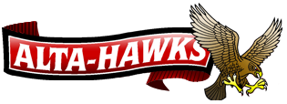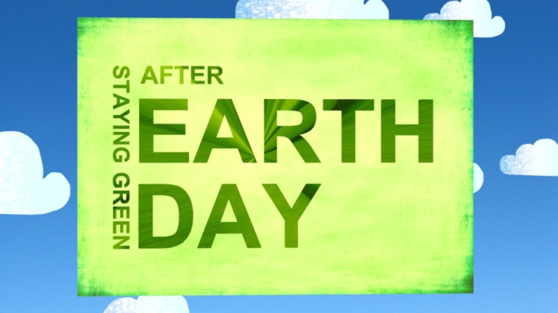

**ALTA HIGH SCHOOL**

**EARTH WEEK 2012**

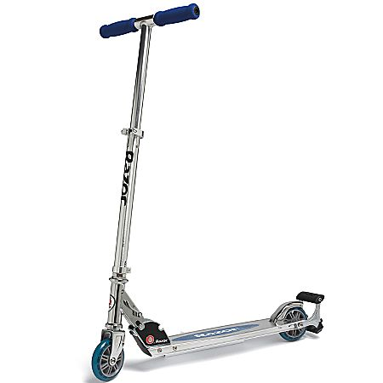

**SCOOTER PASS**

**VALID:**

**APRIL 23 – APRIL 27TH**

**ALTA HIGH SCHOOL**

**EARTH WEEK 2012**

**SCOOTER PASS**

VALID THRU:

APRIL 23 – AP

**Authorized by Alta High School’s Earth Club**



CARD IS NOT INTENDED TO PREVENT CONFISCATION OF SCOOTER,

BUT TO PROMOTE EARTH WEEK 2012

PLEASE RECYCLE CARD AFTER USE